# CS 255 System Design Document Template

## UML Diagrams

### UML Use Case Diagram

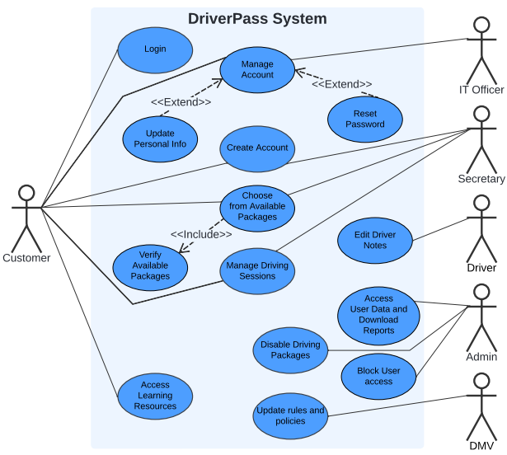

### UML Activity Diagrams

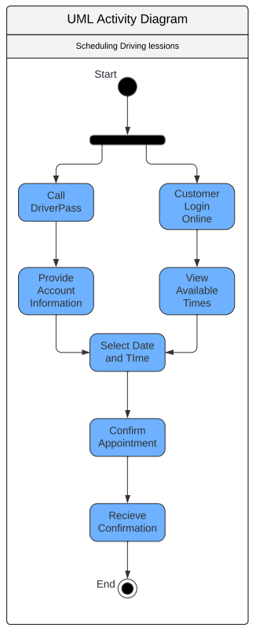

### 

### UML Sequence Diagram

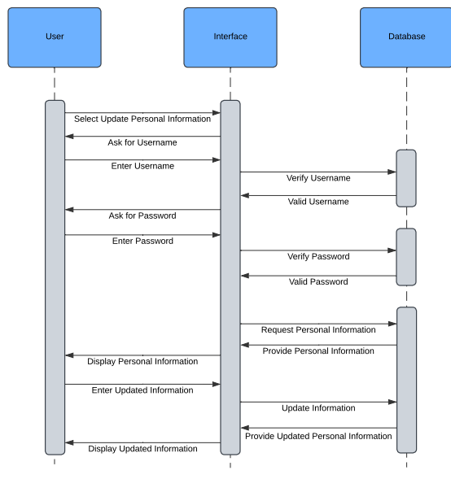

### UML Class Diagram

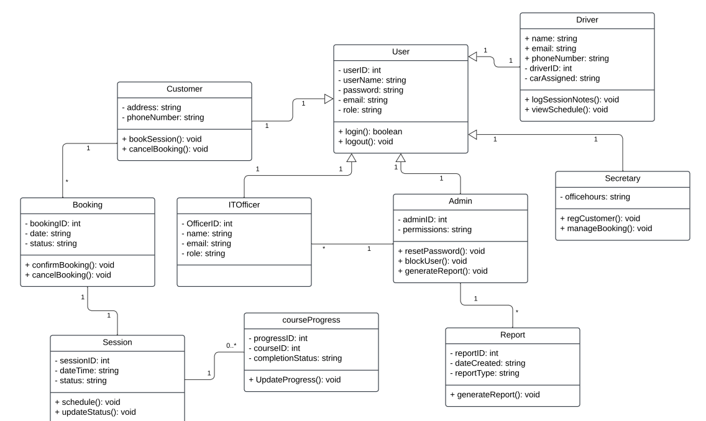

## Technical Requirements

To build and maintain the DriverPass system effectively, the following technical resources are needed:

Hardware Requirements

1. Servers  
   The server will run on secure, cloud-based servers. This means it won’t be limited to a physical location and can be accessed from anywhere with an internet connection.
   1. Cloud hosting, such as AWS or Azure, will be used to ensure that the system can handle many users at one time without crashing or slowing down.
   2. The servers will need enough processing power and memory to store and manage user data, course content, driving session schedules and reports.
2. User Devices
   1. Customers, employees and administrators will access the system through web browsers on a variety of internet-accessible devices, such as cellphones, tablets, desktop computers and laptops.
   2. The system must be compatible with the latest version of popular web browsers such as Chrome, Firefox and Safari.

Software Requirements

1. Web Application Platform  
   The system will be developed using a web-based platform, making it accessible from any device with an internet connection.
   1. The system will be built using a common web application framework
   2. The system will support mobile responsiveness to ensure the website works well on both computers and mobile devices.
2. Database Management System  
   A secure and reliable database will be needed to store and manage the data for users, driving sessions and progress tracking.
   1. A relational database such as MySQL will be used to organize and maintain customer and session data.
   2. Regular backups of the database will be essential to prevent data loss.
3. Security Software  
   Security software will be implemented to ensure the system is safe from hacking attempts and unauthorized access.
   1. The system will use encryption to protect sensitive data such as customer personal information and payment details.
   2. Firewalls and other security measures will be set up to prevent unauthorized access.
4. Content Management System (CMS)  
   A CMS will allow administrators to manage course content and test materials easily. This system will integrate with the DMV to stay up-to-date with the latest rules and guidelines.

Tools and Infrastructure

1. Cloud Hosting Provider  
   The system will be hosted on a cloud platform such as Microsoft Azure. This ensures that the system is scalable and can handle an increasing number of users over time.
   1. The cloud provider will also manage the hardware infrastructure, allowing for automatic updates, scaling and high availability.
2. Authentication Tools  
   To ensure only authorized users can access the system, role-based authentication tools will be used that assign different levels of access to customers, secretaries, drivers, IT officers and administrators.
   1. The system will include two-factor authentication (2FA) for added security and users must verify their identity through a second method, such as text message or email.
3. Email Services  
   The system will include an email service to send notifications for session bookings and cancellations, as well as password resets to customers and administrators.
   1. Services like SendGrid will be used for reliable email delivery.
4. Reporting Tools  
   The system will include tools to generate reports, such as session logs and user activity data.
   1. These reports will help administrators track system usage and identify any potential issues.

Network and Infrastructure Requirements

1. Internet Connection
   1. The system will require a reliable internet connection to function properly. Since it is a web-based system, access to the system will rely on the availability of the internet.
   2. The system must be able to handle multiple users at one time without slowdowns, so a high-speed internet connection will be essential for smooth operations.
2. Backup Systems
   1. Regular data backups will be performed automatically to ensure that no information is lost. This will allow the system to recover in the event of a technical issue.
   2. The system will also implement failover mechanisms to ensure minimal downtime in the event of any infrastructure issues.

System Updates and Maintenance

1. Automatic Updates
   1. The system will be updated automatically to reflect changes in DMV policies and test materials. This will ensure that the system stays current without requiring manual updates.
2. Scheduled Maintenance
   1. Periodic maintenance will be performed to ensure that the system remains secure, efficient and reliable. This will include things like performance checks, software updates and database optimization.